Literature suggested by Kristian Boroz before the lecture 1:

1. <https://www.youtube.com/watch?v=Prpu_U5tKkE>
2. 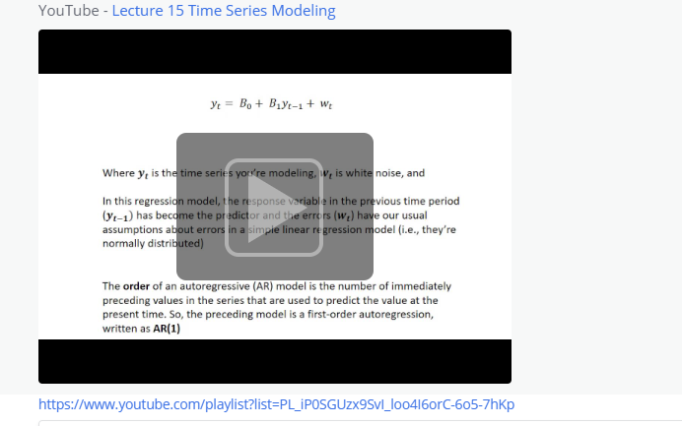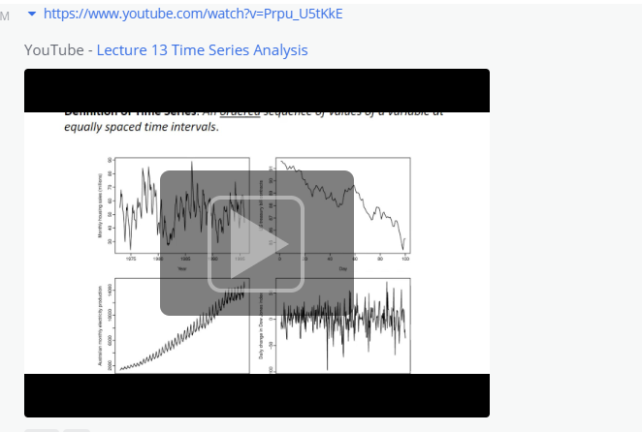
3. [https://www.youtube.com/playlist?list=PL_iP0SGUzx9SvI_loo4I6orC-6o5-7hKp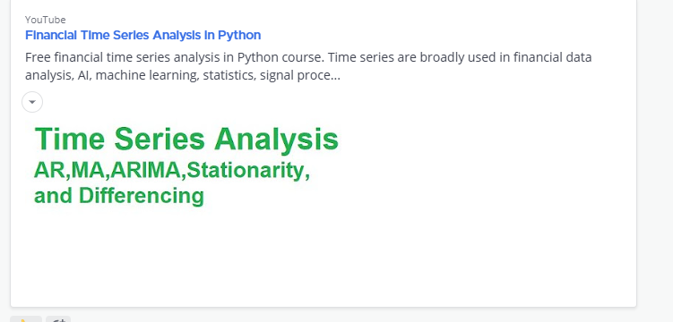](https://www.youtube.com/playlist?list=PL_iP0SGUzx9SvI_loo4I6orC-6o5-7hKp)
4. <https://www.youtube.com/playlist?list=PLqYFiz7NM_SMC4ZgXplbreXlRY4Jf4zBP>
5. 